# AquaNest – Water Delivery Website

## 1. Project Overview

AquaNest is a full-stack web application designed for a fictional water delivery company. It offers customers a modern, seamless experience to browse water products (bottles, gallons, dispensers), place and track delivery orders, and interact with the company through a responsive and visually appealing interface.

The project focuses on:

- Smooth user interface and experience (UI/UX).

- Functional order management system.

- Admin panel for backend control.

- Animated transitions and motion graphics to enhance interactivity.

- Clean code structure, Git workflow, and thorough documentation.

## 2. Objectives

- Develop a complete web-based solution for a water delivery service.

- Implement an intuitive ordering and checkout experience.

- Build an admin interface for order and product management.

- Ensure mobile responsiveness, scroll animations, and smooth transitions.

- Follow industry-standard Git workflow, code practices, and DevOps deployment.

## 3. Tech Stack

Frontend: React.js, Tailwind CSS, Framer Motion

Backend: Node.js, Express.js

Database: MongoDB (Mongoose ODM)

Authentication: JWT, bcrypt

Deployment: Vercel (Frontend), Render (Backend)

DevOps: GitHub (branches, PRs, commits)

## 4. Features

**Public Pages:**

- Home: Animated hero with parallax.

- About Us: Company mission with motion graphics.

- Products: Filterable list.

- Testimonials: Carousel format.

- Contact: Google Maps embed and form.

**User Features:**

- Register/Login (JWT based)

- Cart system and checkout

- Order tracking (status progress bar)

- Order history

**Admin Features:**

- Dashboard access with login

- CRUD operations on products

- Update and manage order statuses

## 5. UI/UX & Animations

- Framer Motion used for text entrance, section transitions, page routing.

- Tailwind ensures full mobile responsiveness.

- Visual design with modern colors, layout, and accessibility in mind.

## 6. System Architecture

- Frontend communicates with backend via RESTful API.

- JWT-based secure auth system.

- Mongoose schemas manage data.

- Admin access controlled via middleware.

- Order progress calculated dynamically.

## 7. API Endpoints Overview

GET /api/products - Fetch all products

POST /api/users/register - User registration

POST /api/users/login - Login

GET /api/orders/user/:id - Order history

POST /api/orders - Place new order

PUT /api/orders/:id/status - Update status (admin)

## 8. Git Workflow

- Feature-based development branches.

- Commits with clear, descriptive messages.

- Pull Requests for each completed feature.

- GitHub Issues used for bug and task tracking.

## 9. Screenshots (Description)

- Homepage: Hero, motion effects

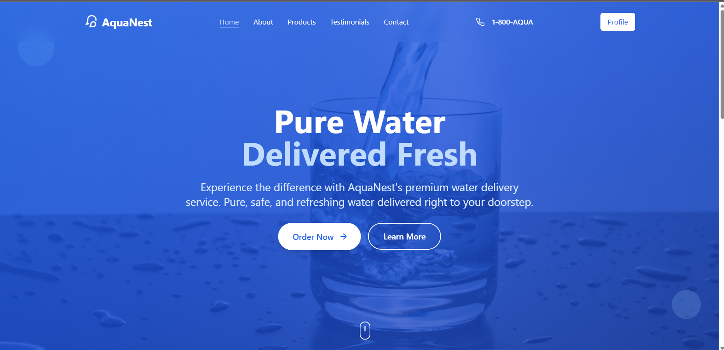

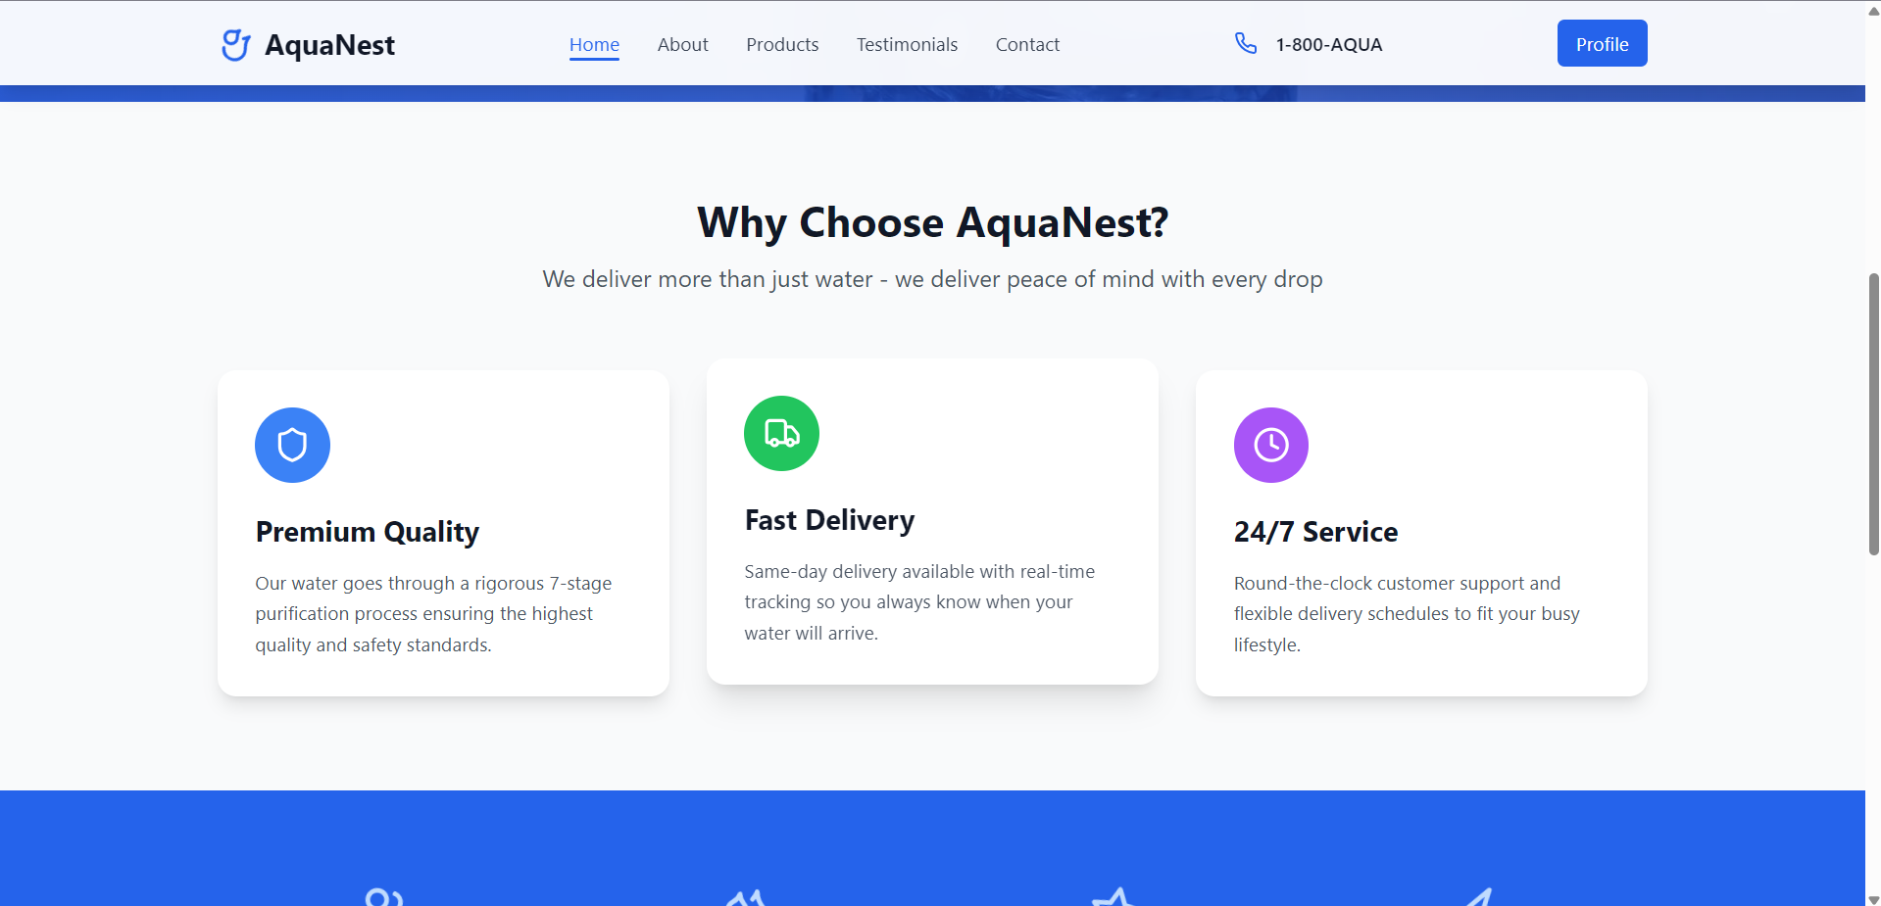

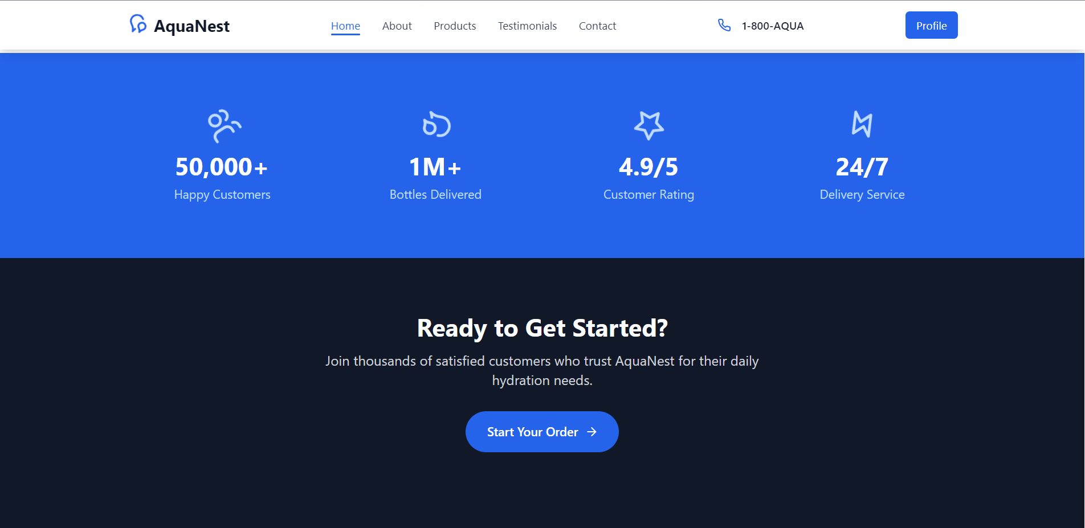

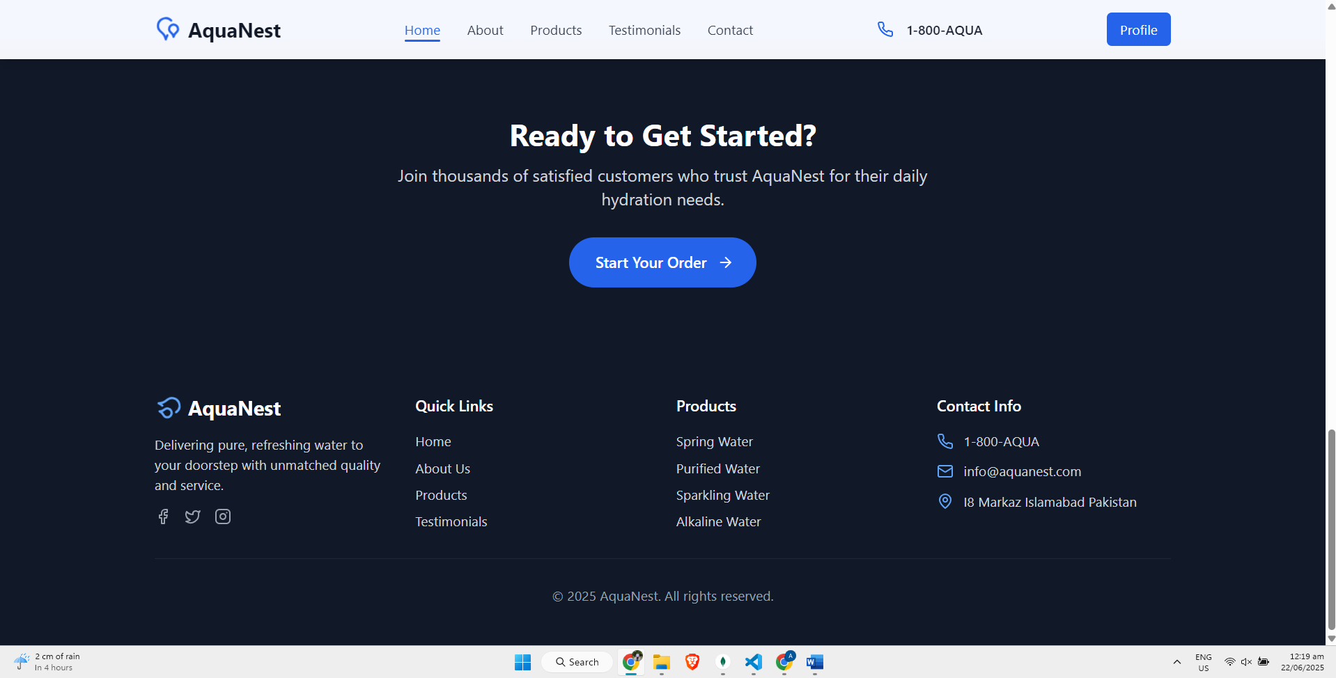

- Products: Filter, UI grid

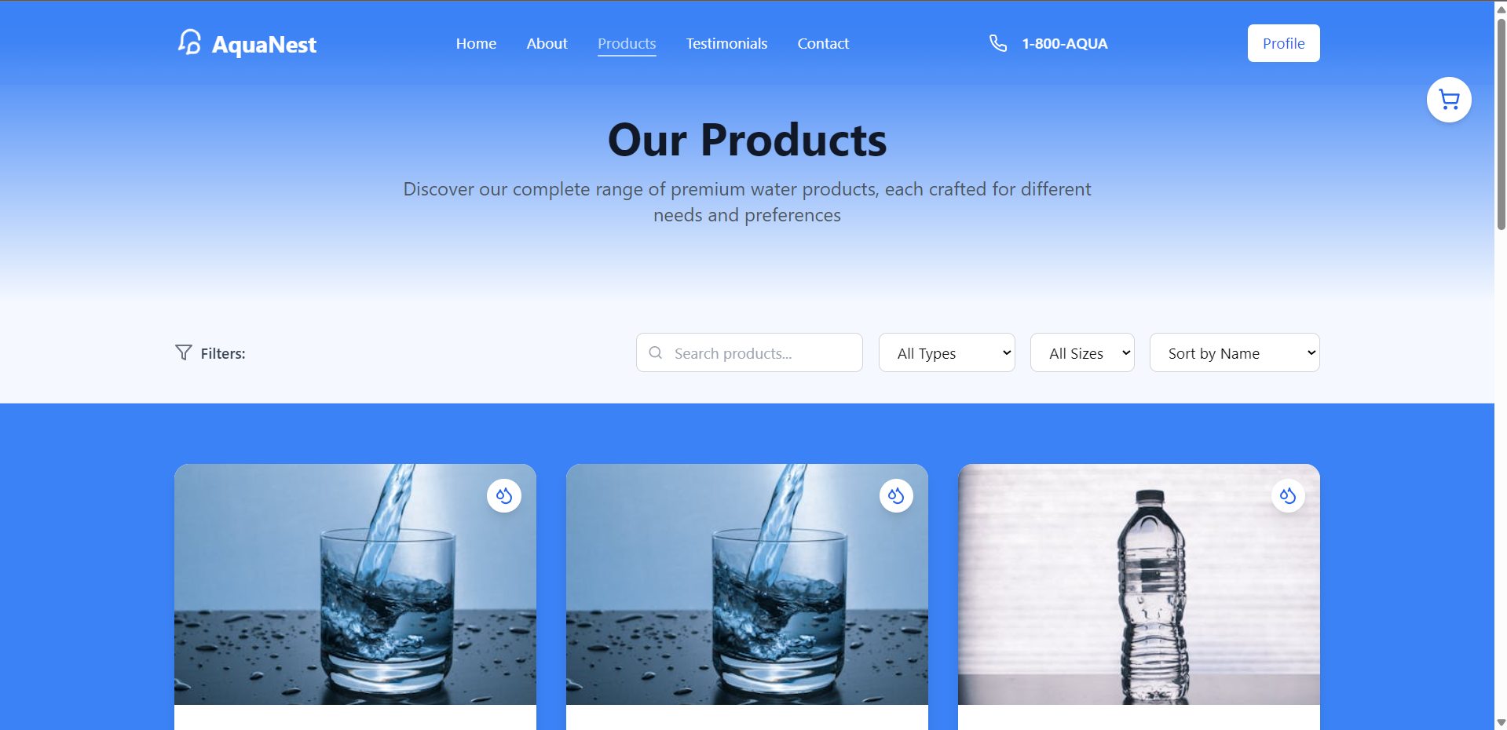

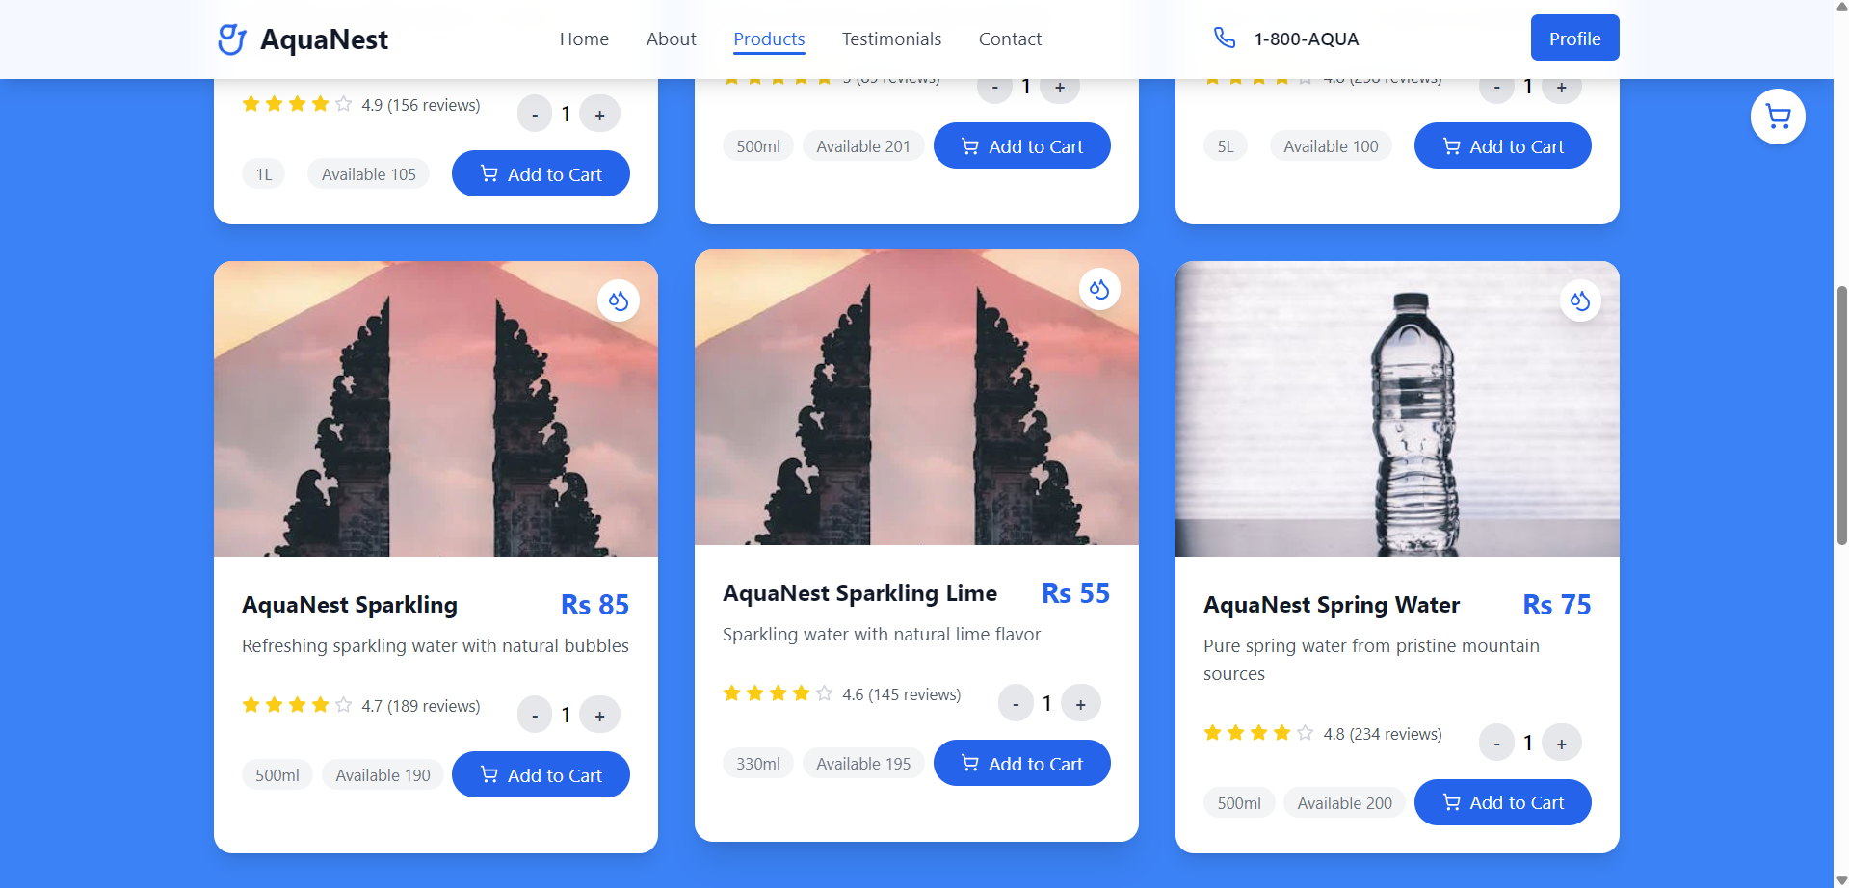

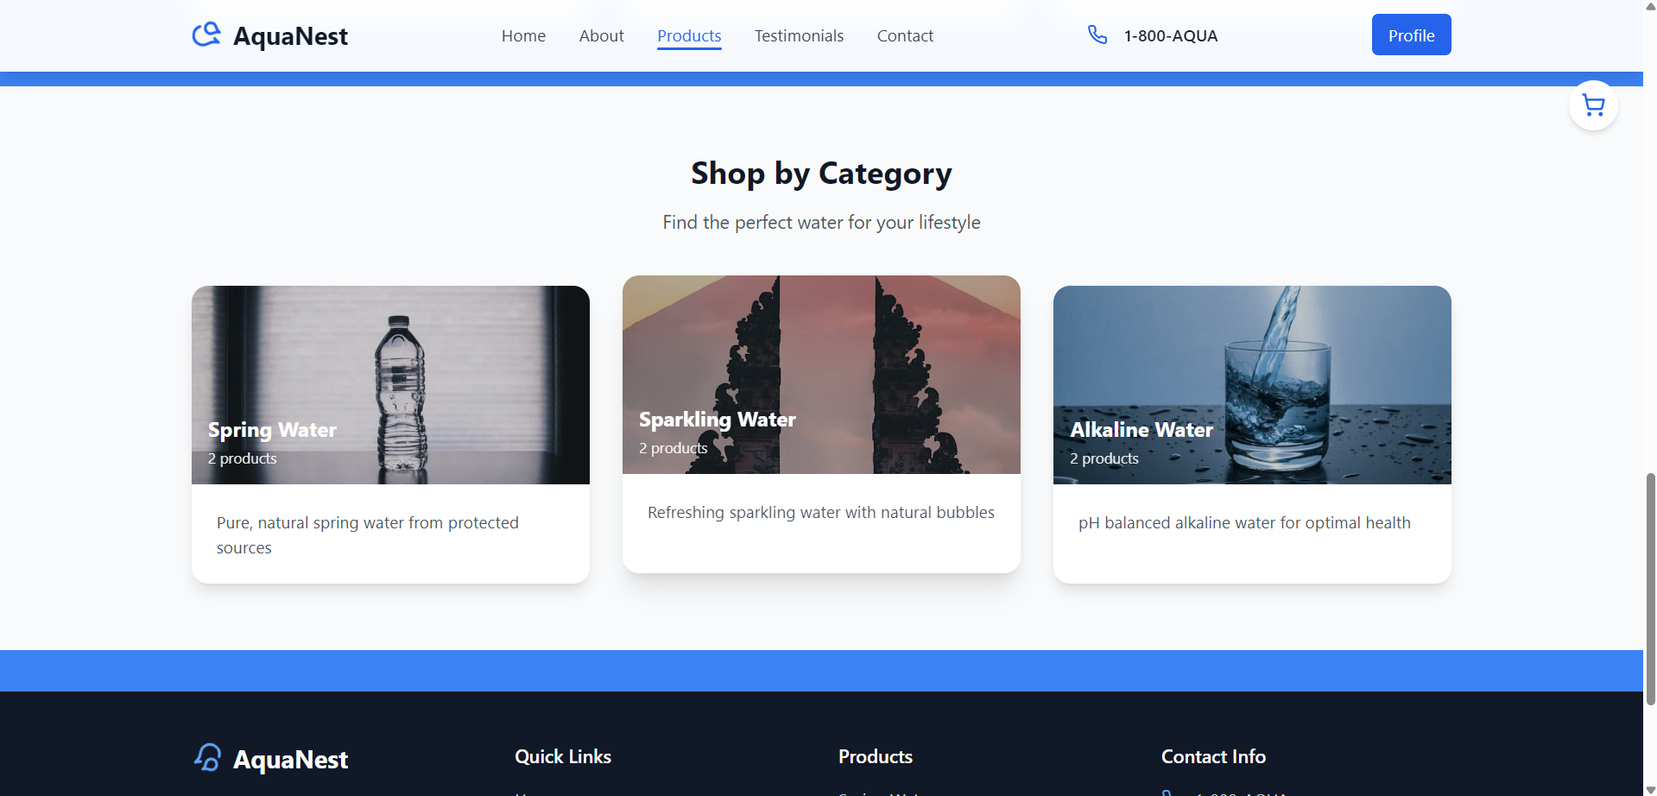

- Cart: Add/remove, update quantity

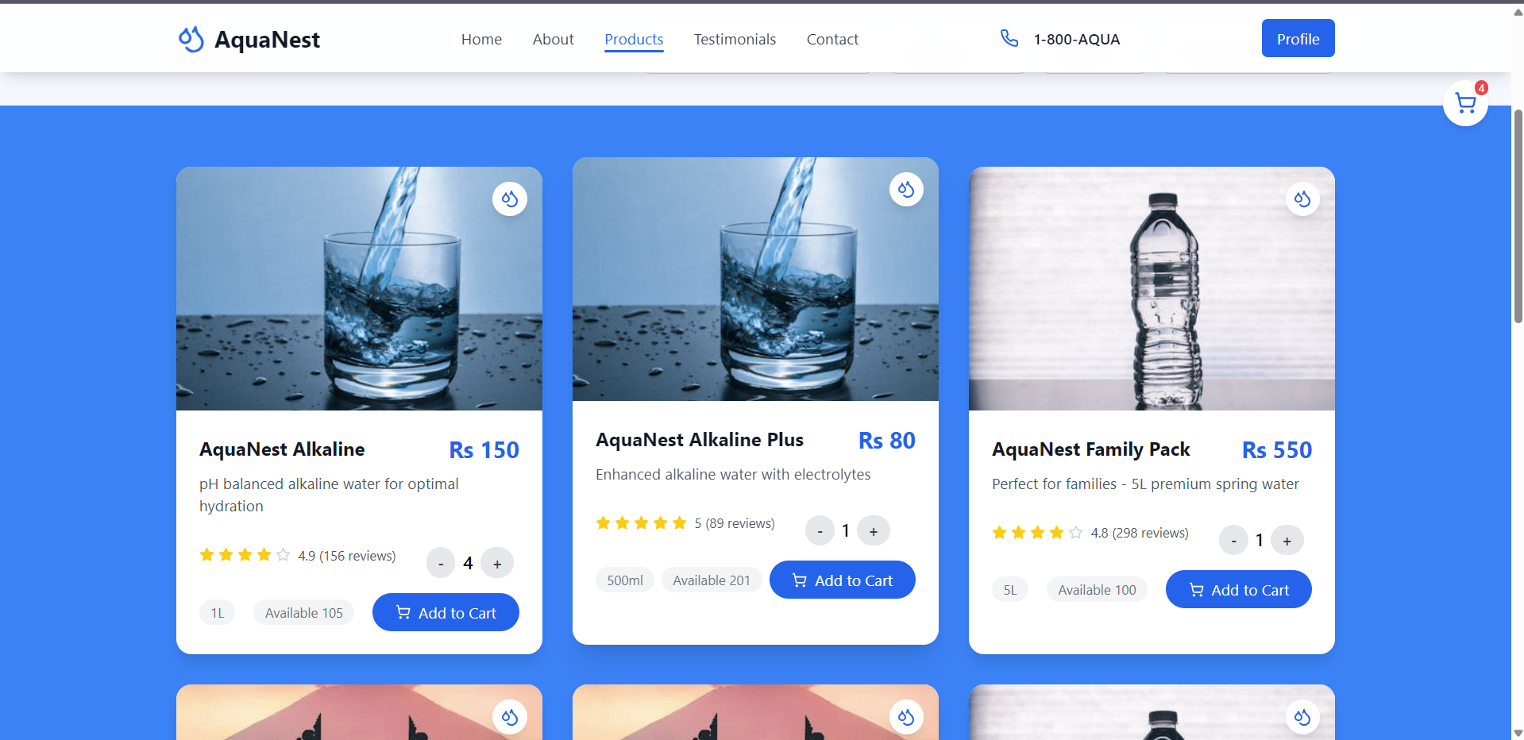

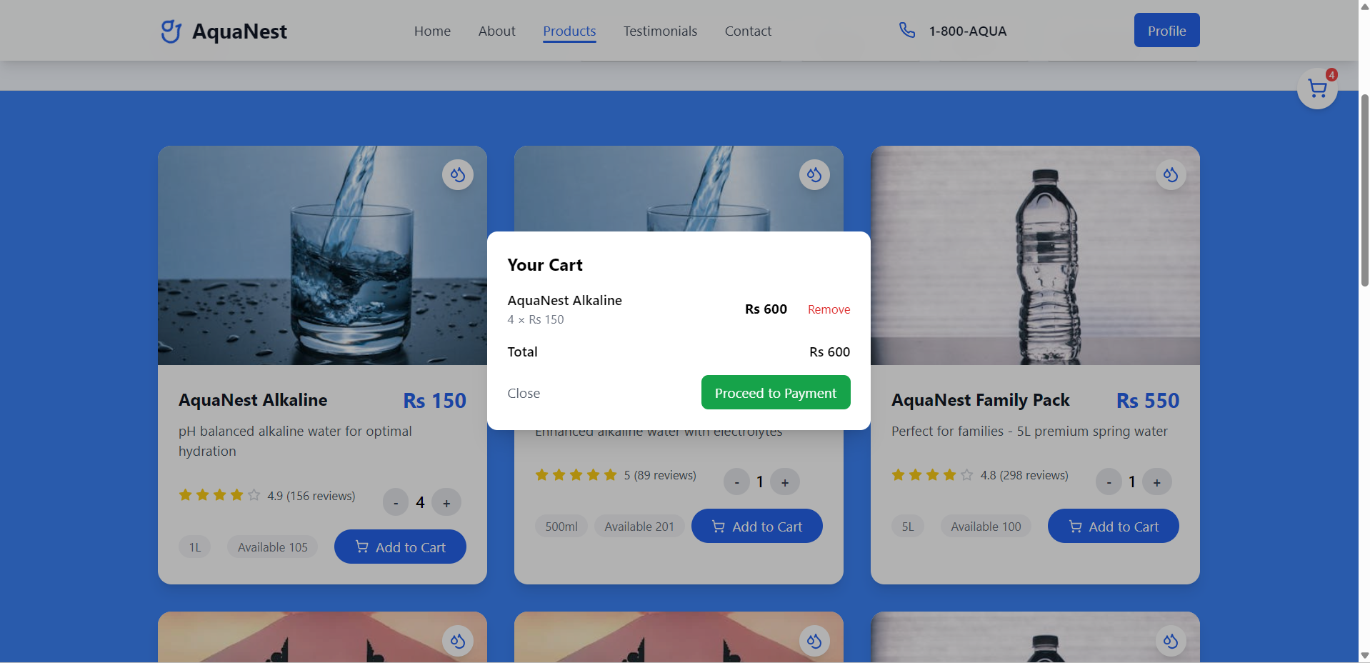

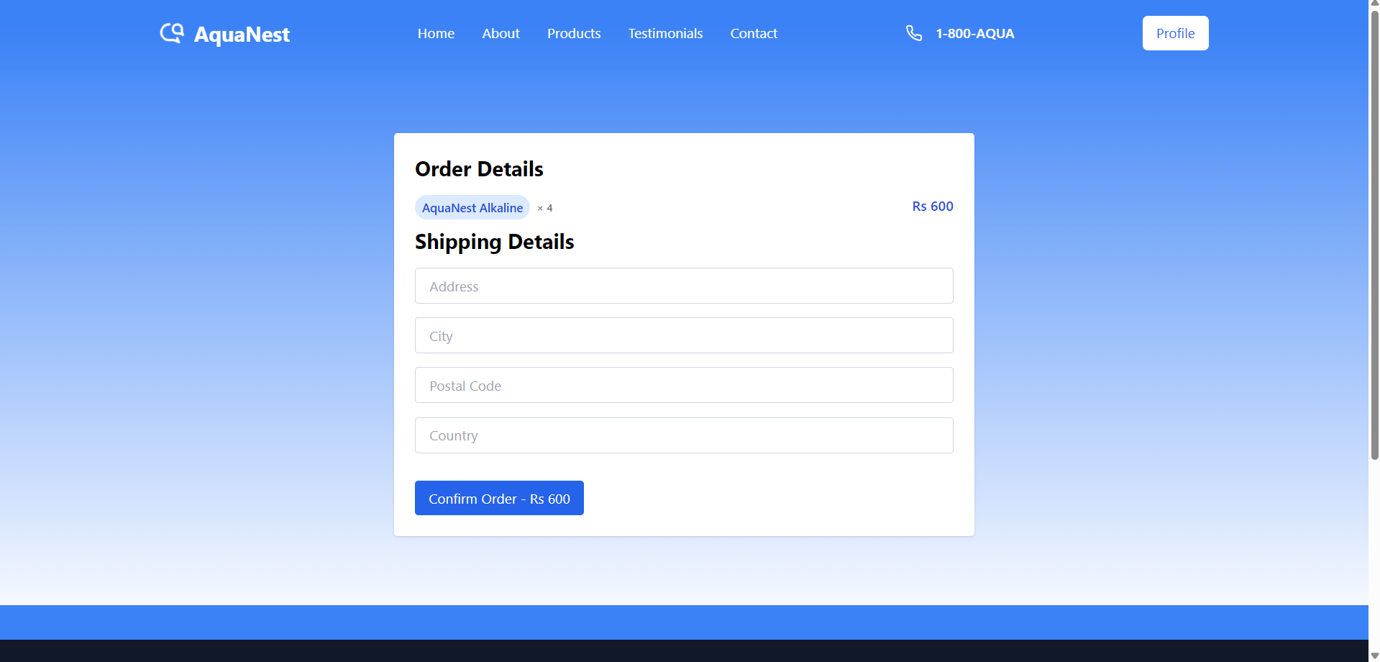

- About us: Mission statement and vision

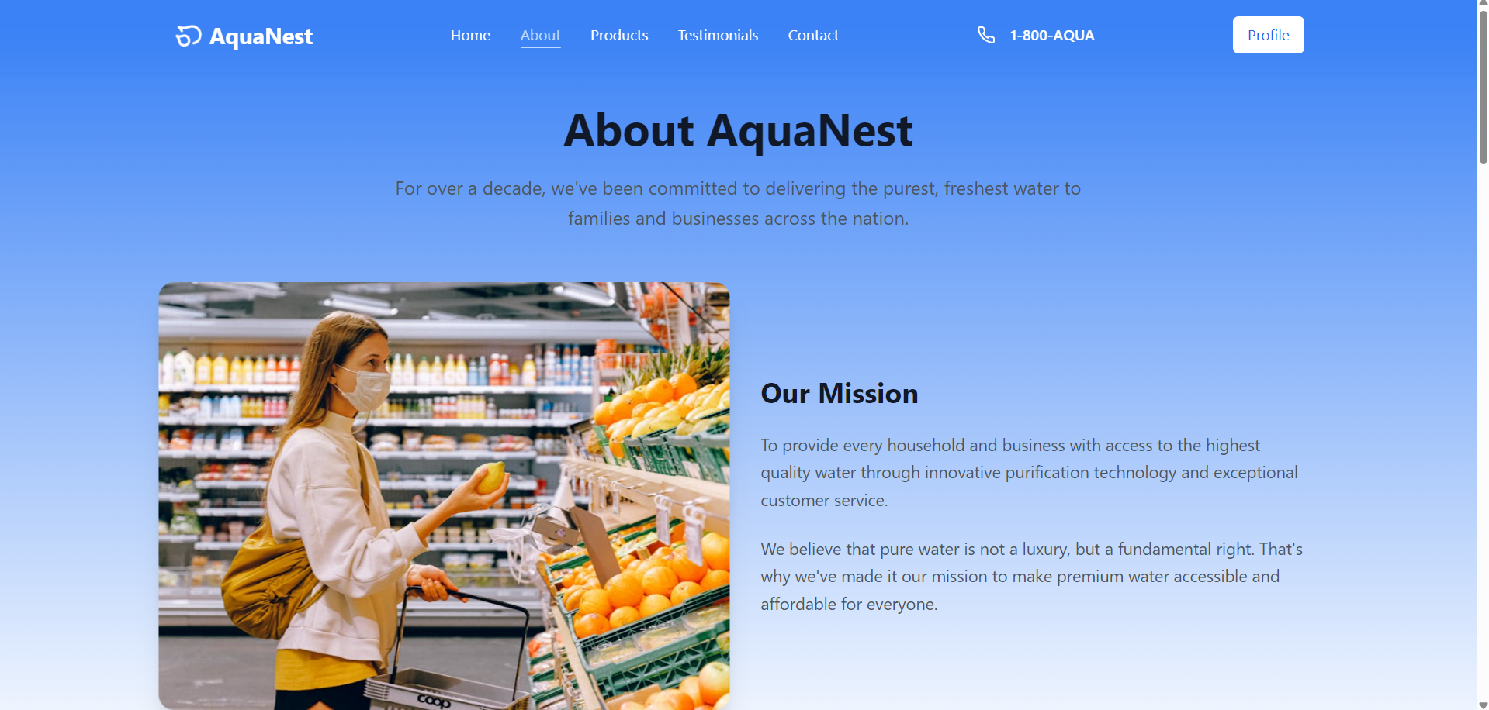

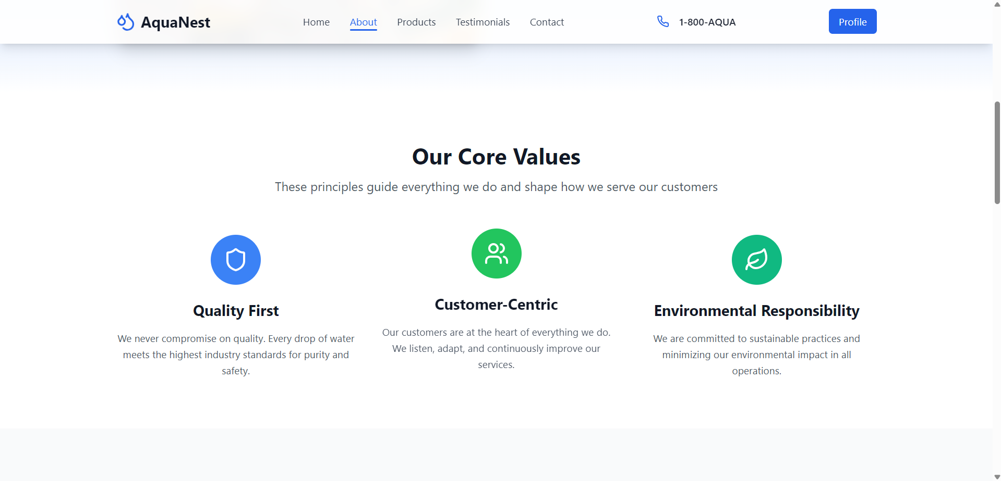

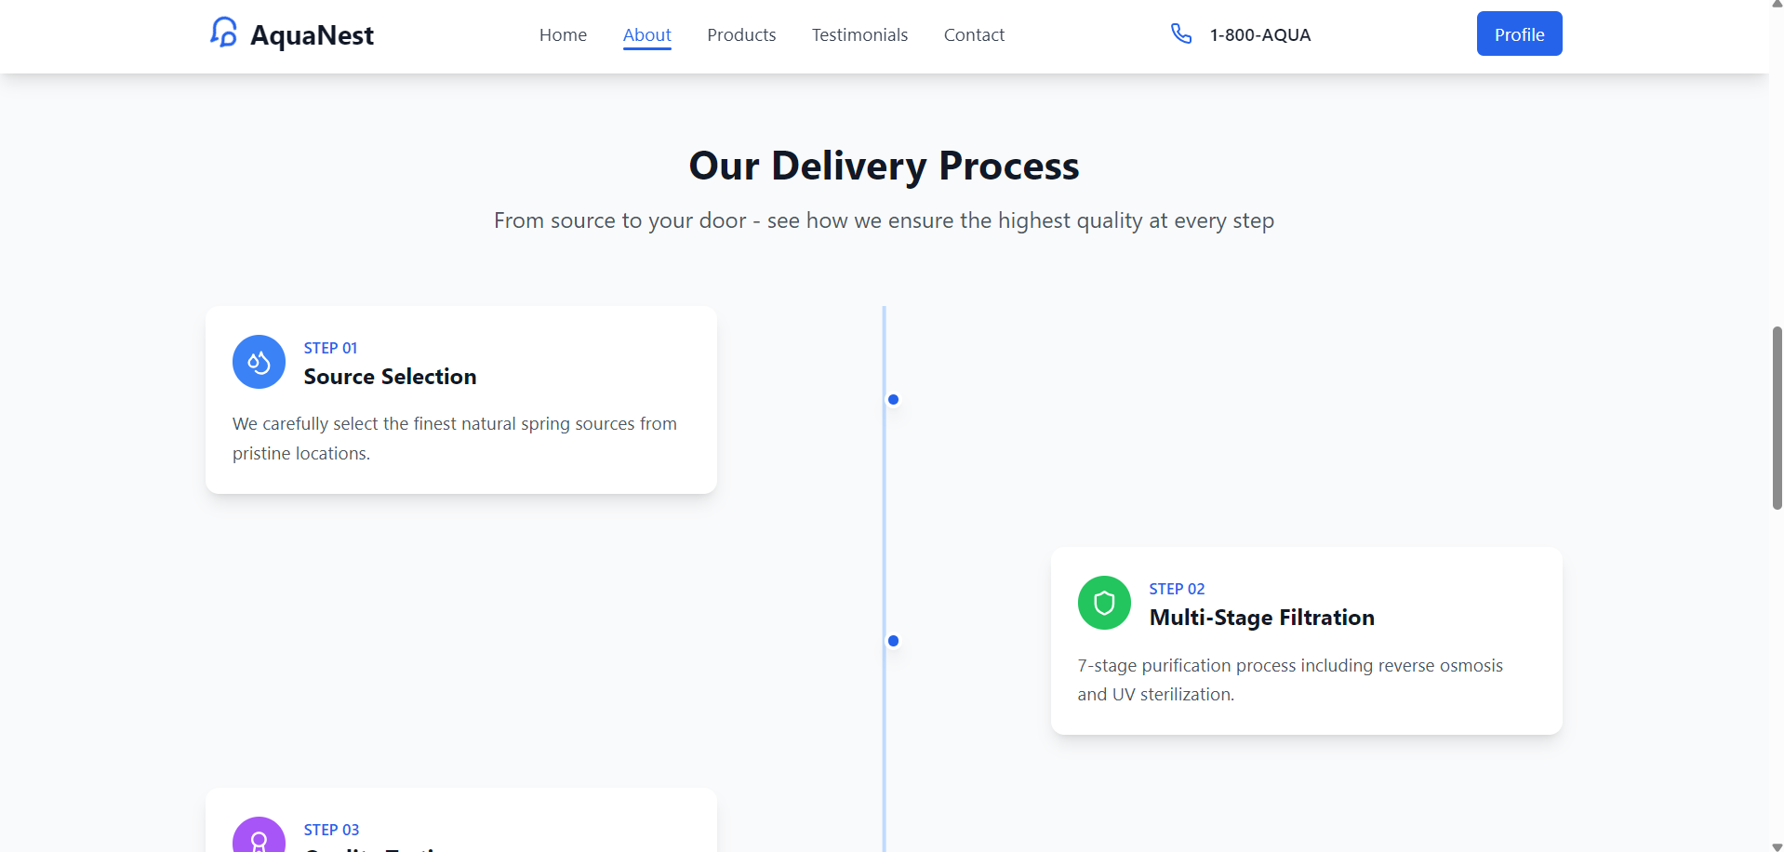

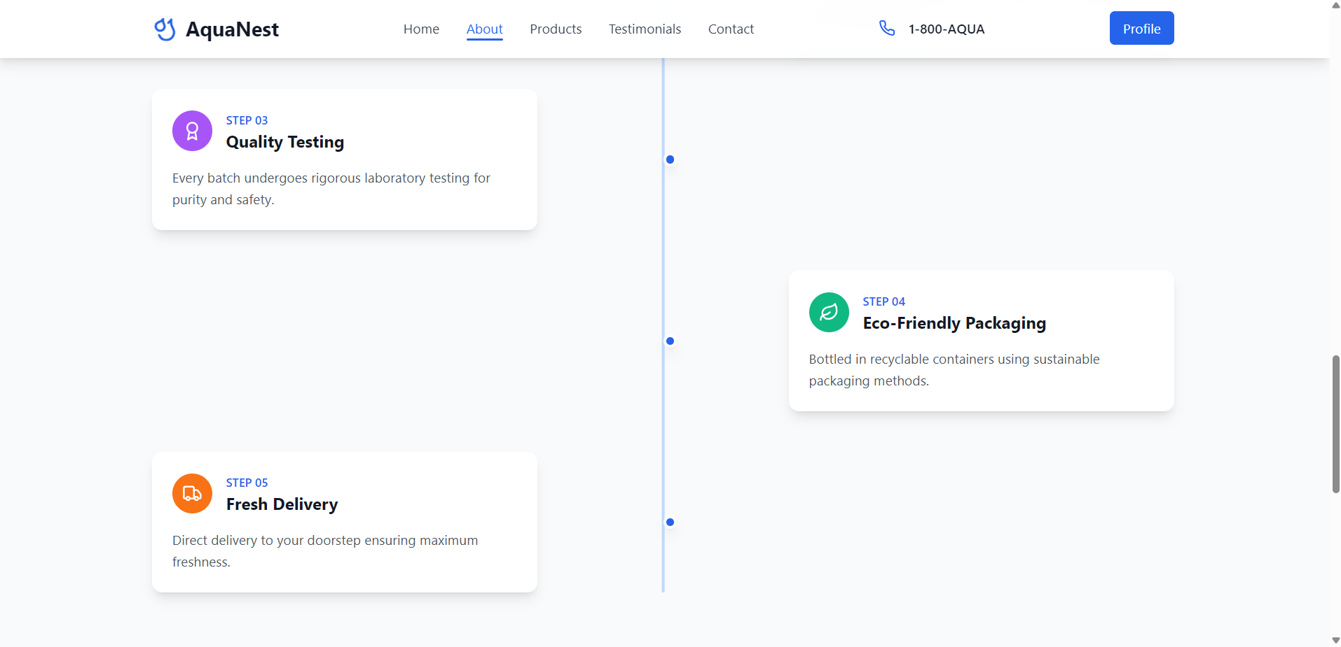

-Testimonial: Mission statement and vision

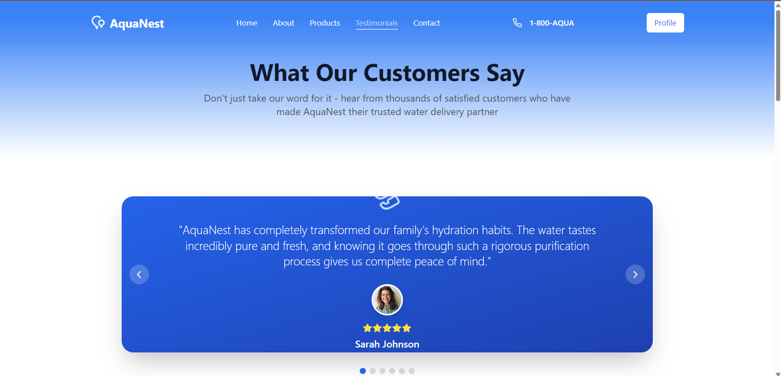

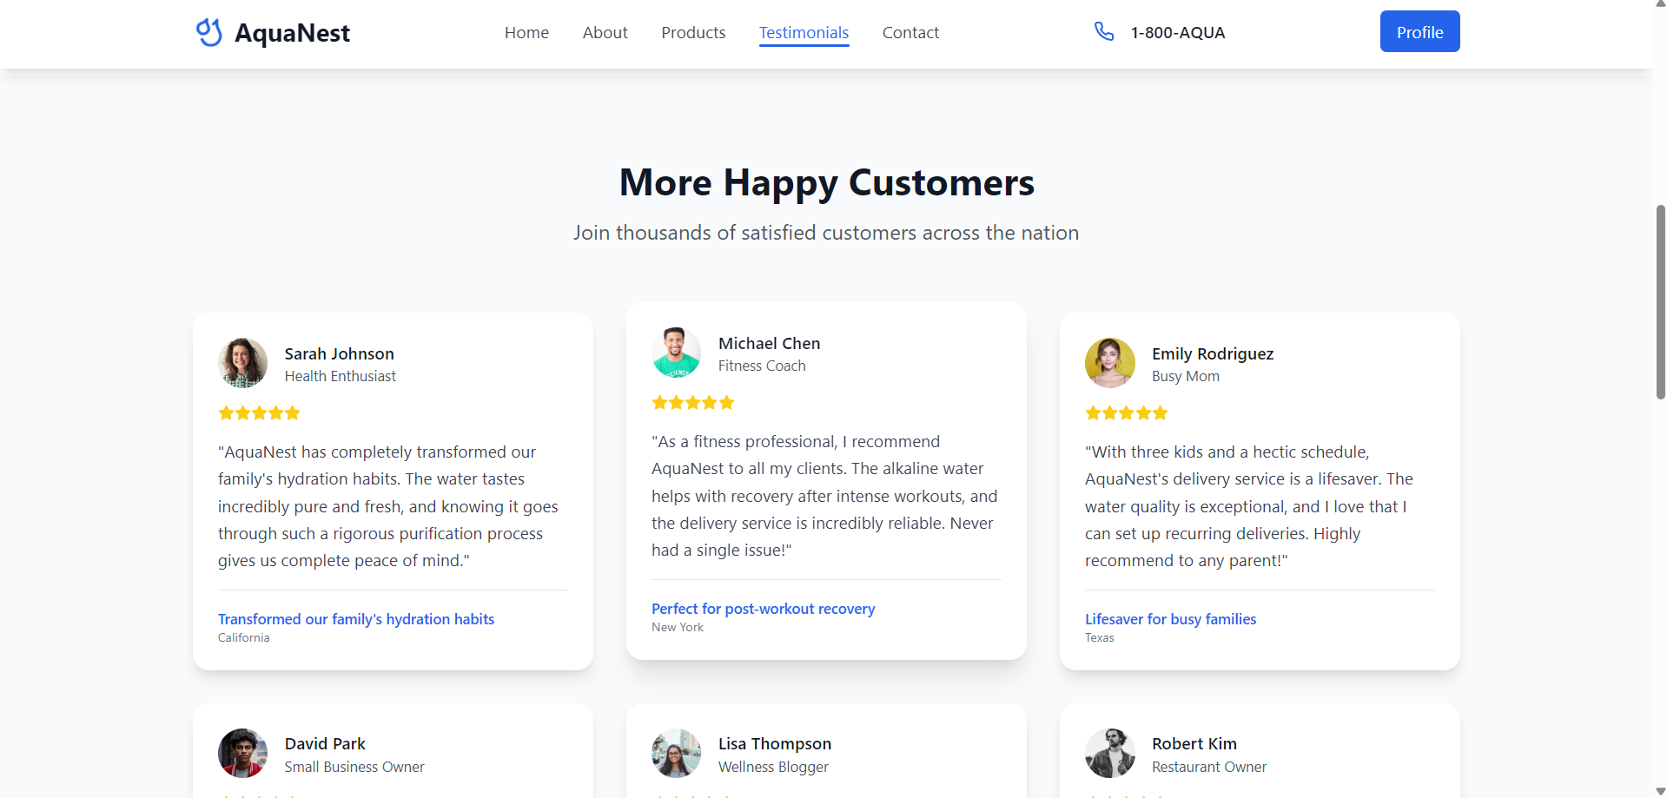

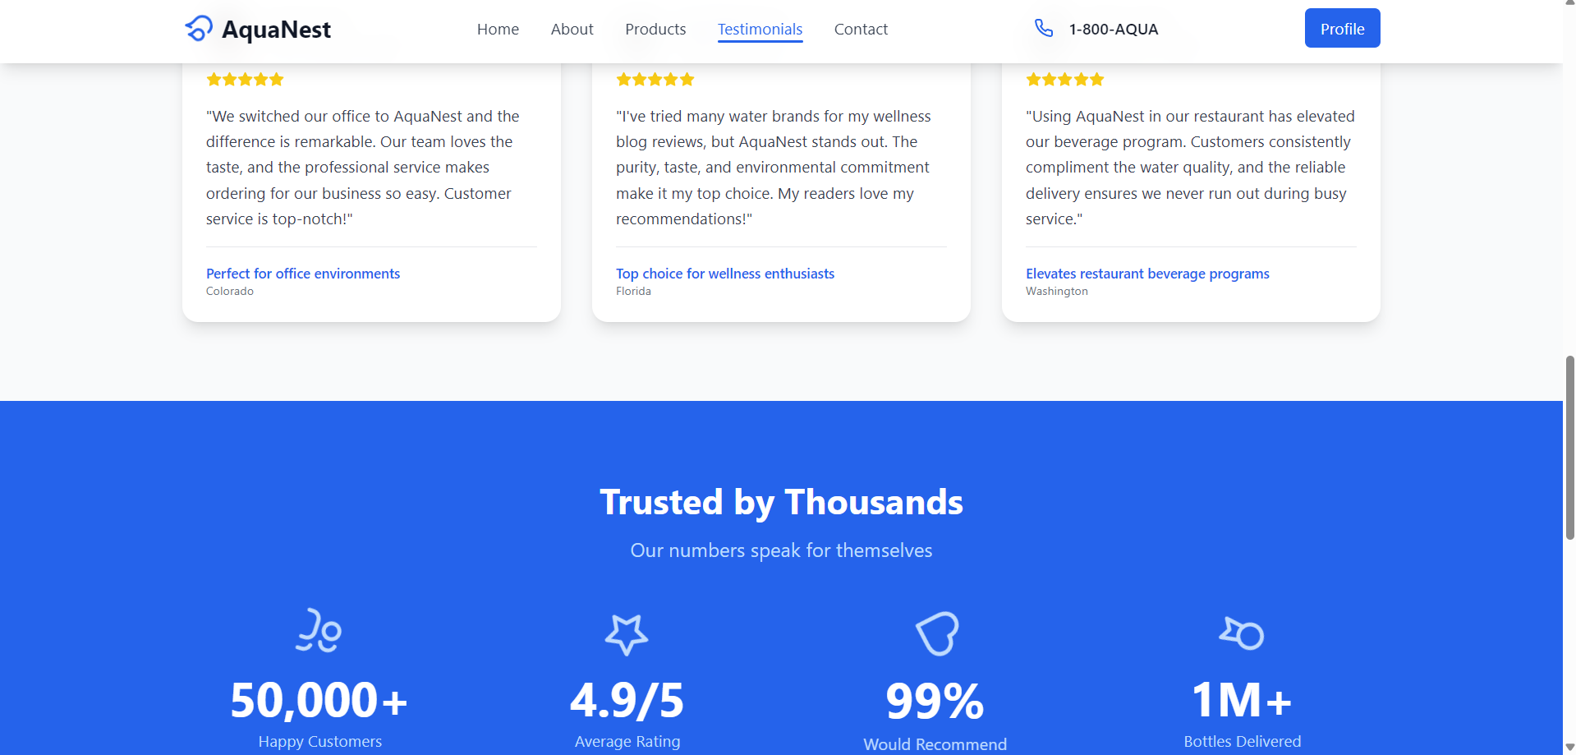

- Contact: Contact form and descriptions

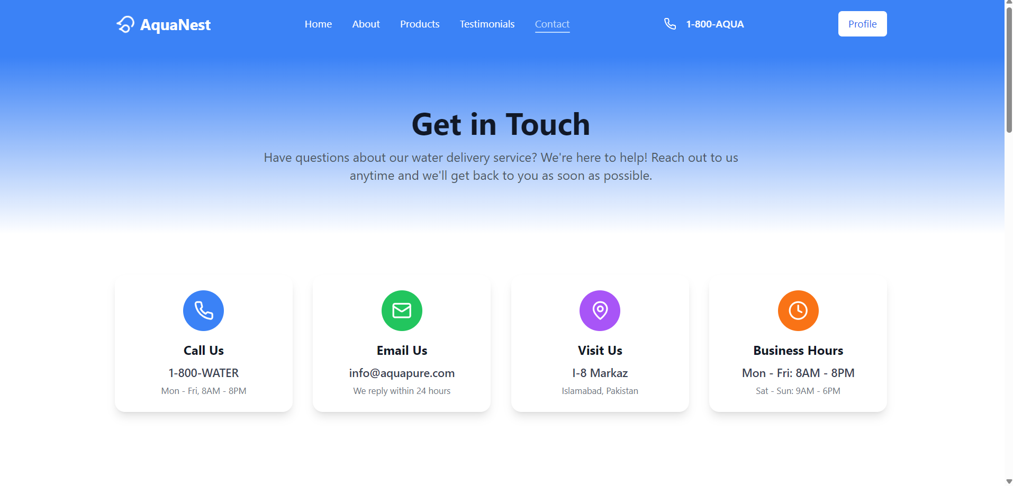

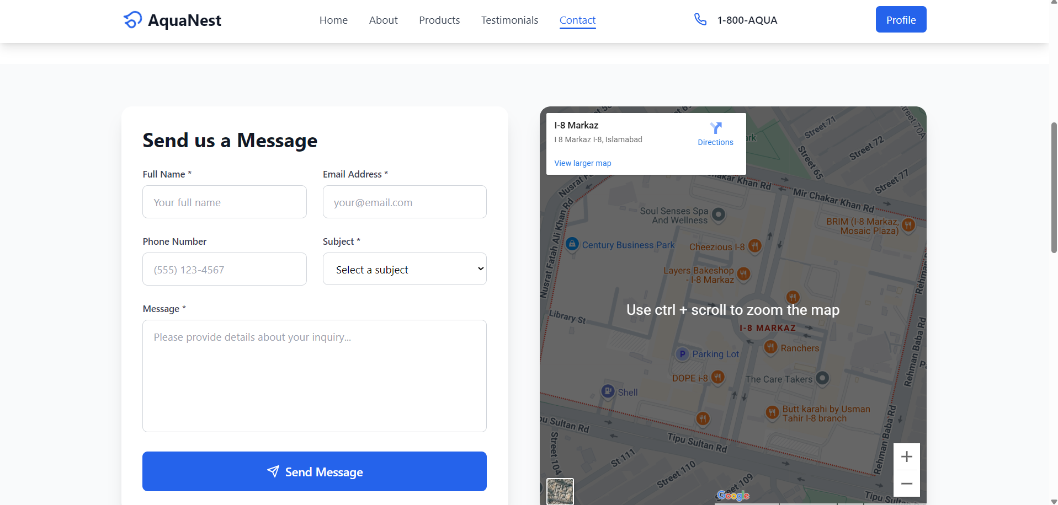

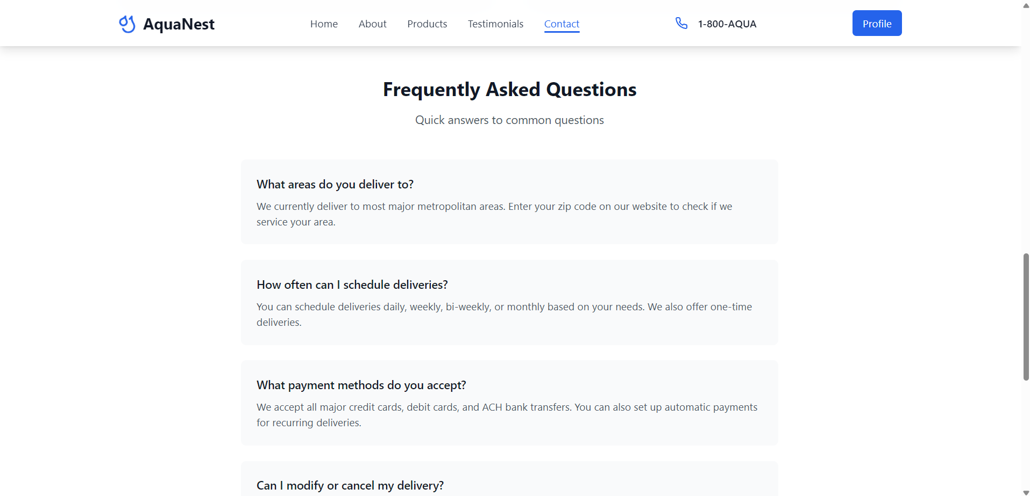

- Orders: Status bar and timeline

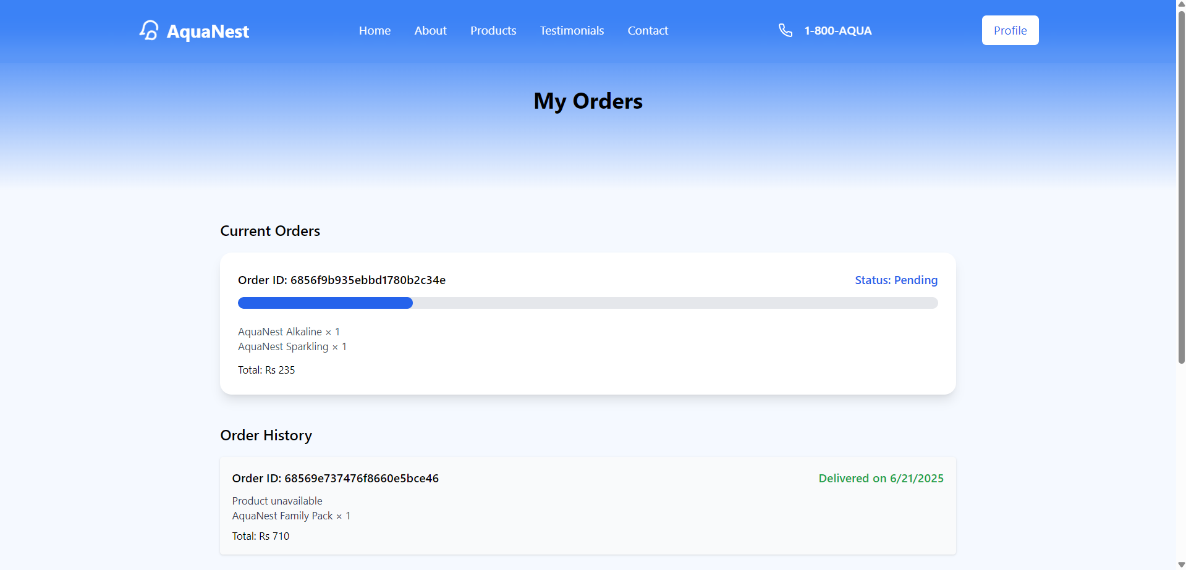

- Admin: Order and product control

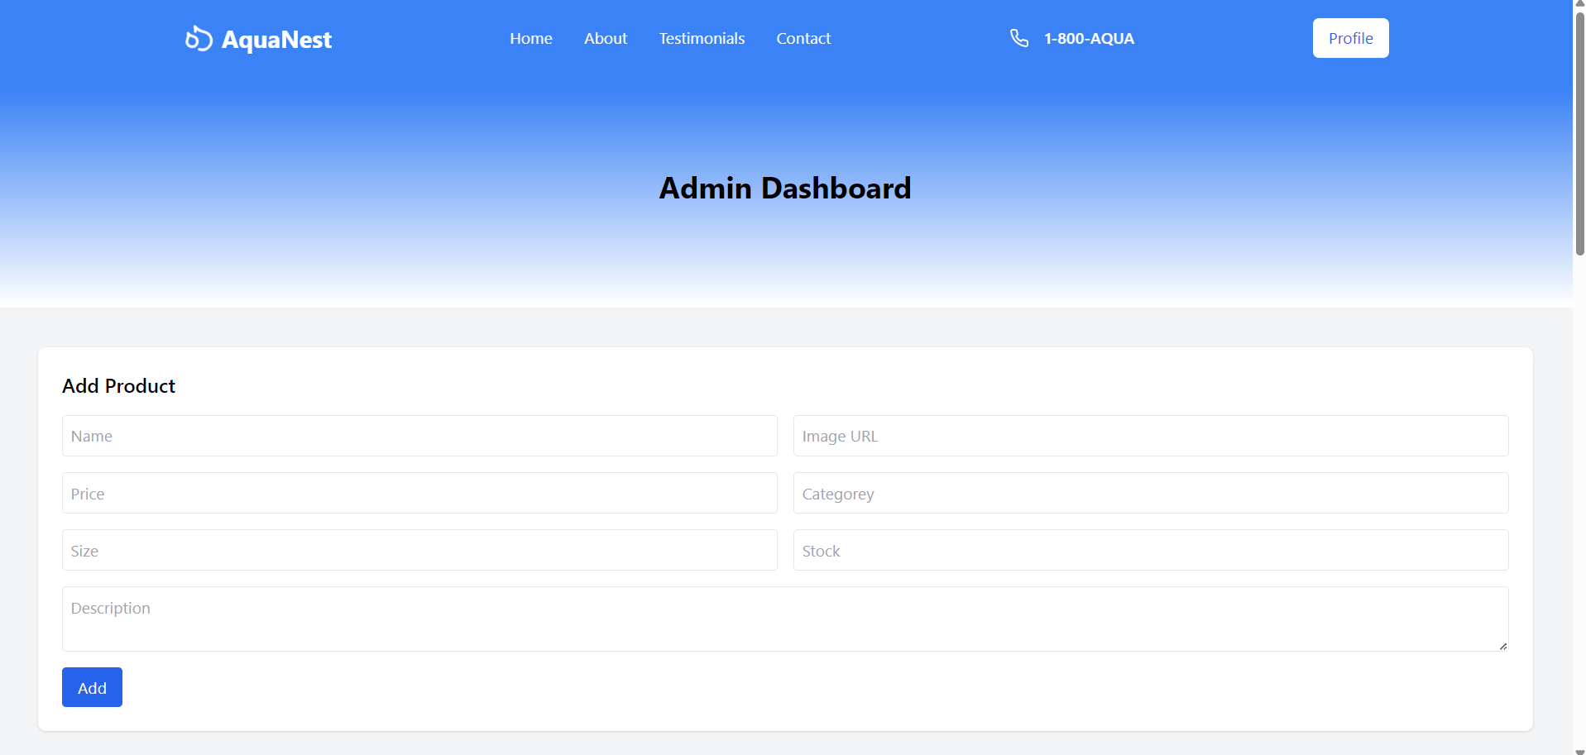

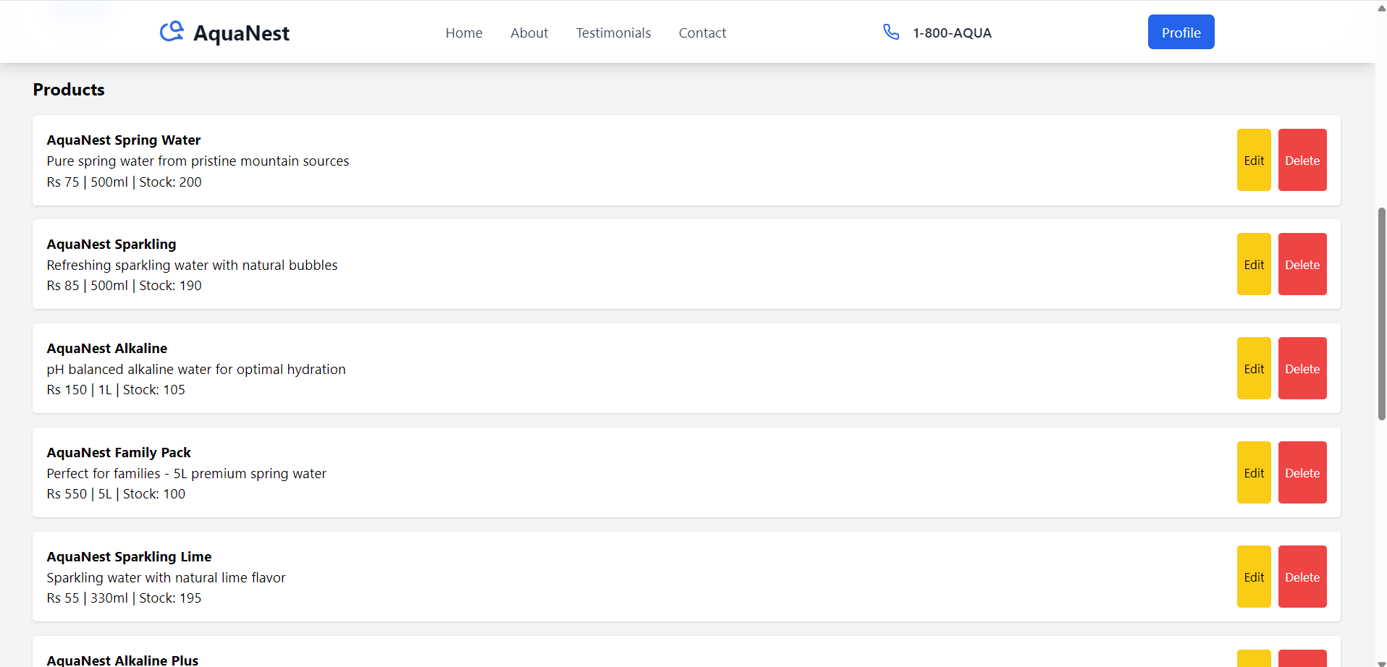

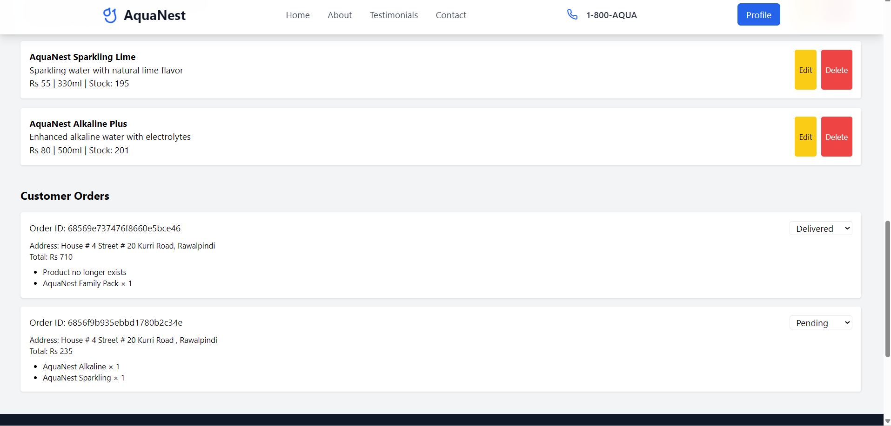

- Mobile view: Fully responsive

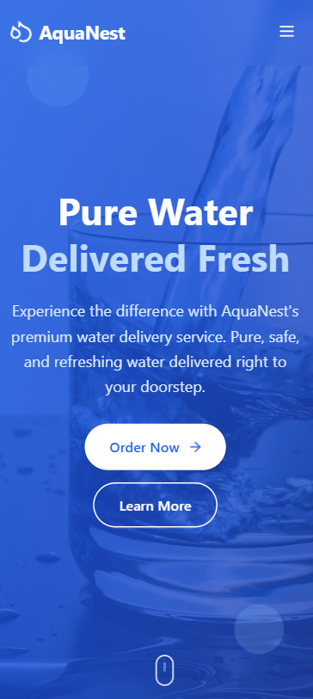

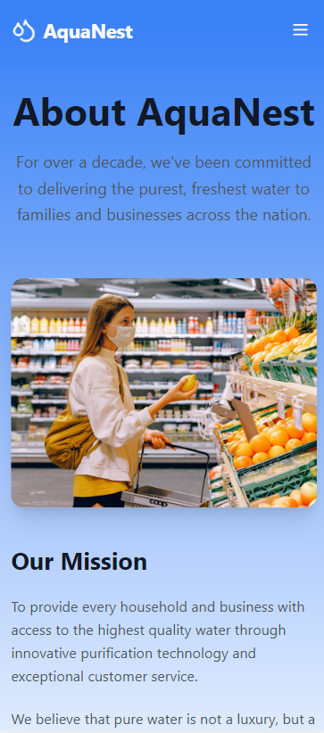

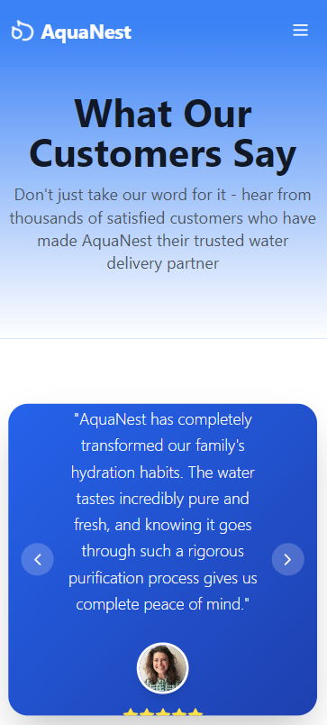

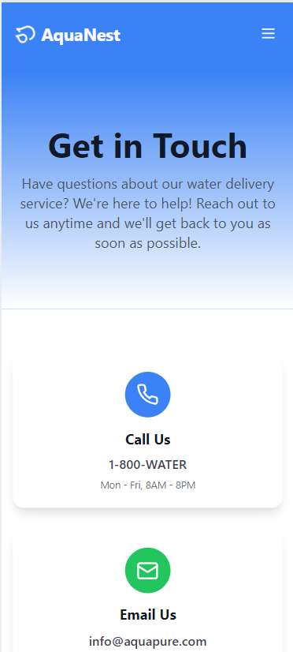

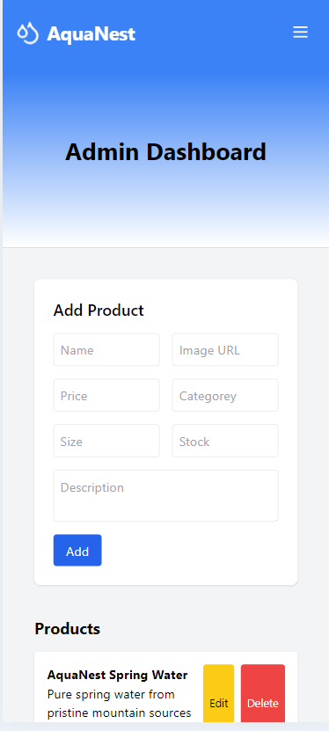

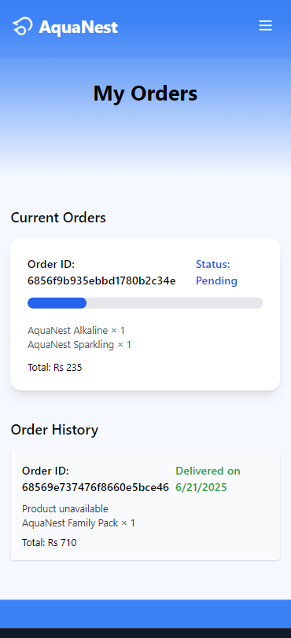

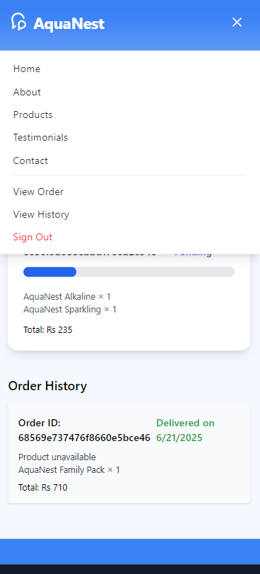

## 10. Deployment

Frontend: Vercel

Backend: Render

Live Links: Provided for both

CI/CD connected to GitHub repo

## 11. Evaluation Highlights

UI/UX Design: 25%

Functionality: 20%

Animations: 15%

Backend Integration: 15%

Git Usage: 10%

Documentation: 10%

Creativity: 5%

## 12. Challenges & Solutions

- Auth state: Managed with JWTs and middleware.

- Animation performance: Debounced scroll, Framer Motion optimizations.

- State management: Modular design and hooks.

## 13. Future Improvements

- PWA support

- Delivery tracking with maps

- Admin charts with Chart.js

- Stripe payment integration

- Email notifications

## 14. Conclusion

AquaNest is a modern, fully integrated full-stack platform demonstrating proficiency in frontend, backend, animations, and responsive UI. The documentation and structure support further development and industrial deployment.